**Create Lambda User Defined Function for Calling Athena Data Queries**

# **Introduction**

This tutorial guides you through creating an AWS Lambda function designed to execute Amazon Athena data queries. Learn to configure a Python runtime environment, set up triggers, and deploy the function, enabling efficient and automated querying capabilities within your cloud infrastructure for streamlined data analysis and retrieval.

# **Let's get Started**

**Access AWS Lambda Console:**

* Navigate to the [AWS Lambda console](https://us-west-2.console.aws.amazon.com/lambda/home?region=us-west-2#/discoverhttps://us-west-2.console.aws.amazon.com/lambda/home?region=us-west-2#/discover) at the provided URL. This will take you directly to the Lambda service in the AWS console within the US West (Oregon) region.

**Create a New Function:**

* Click "**Create function**" to begin the process of setting up a new Lambda function.

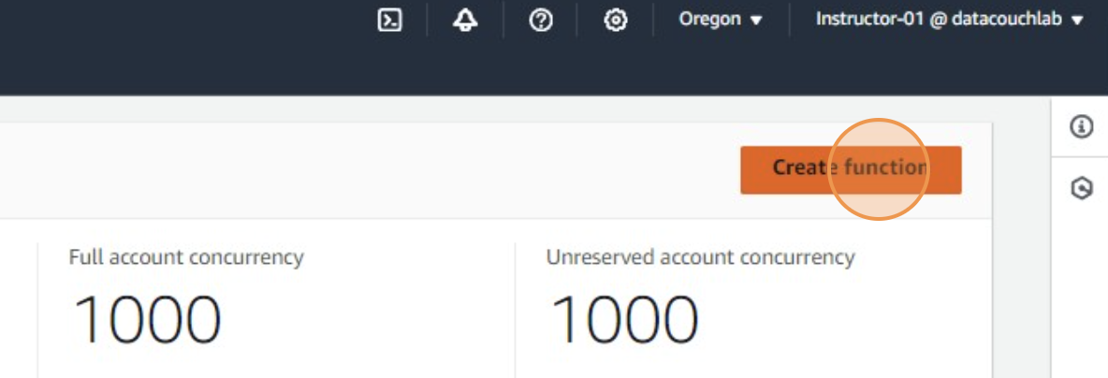

**Set Function Name:**

* Click on the "**Function name**" field and type the name for your Lambda function, such as "**lambda_Calling_Athena_Data_Queries**". This name should be descriptive and relate to the function’s purpose.

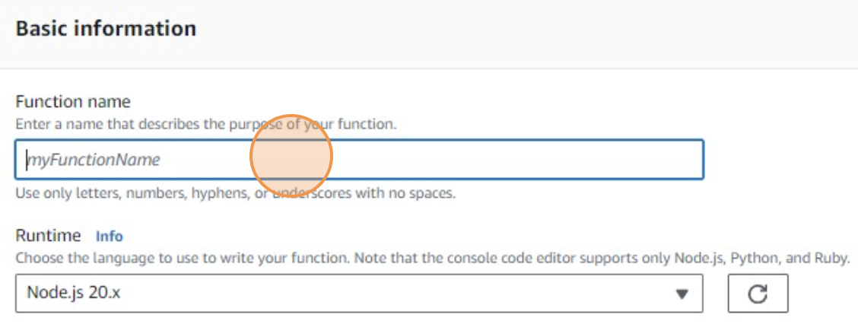

**Select Runtime:**

* Choose the runtime environment for your Lambda function. If you click "**Node.js 20.x**" and then "**Python 3.12**", it suggests you are selecting Python 3.12 as the runtime, which is appropriate for running Python scripts.

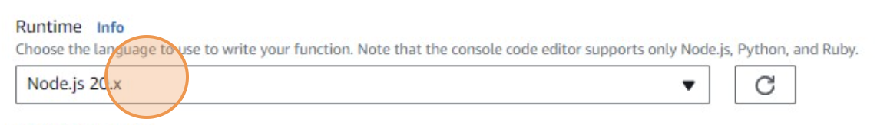

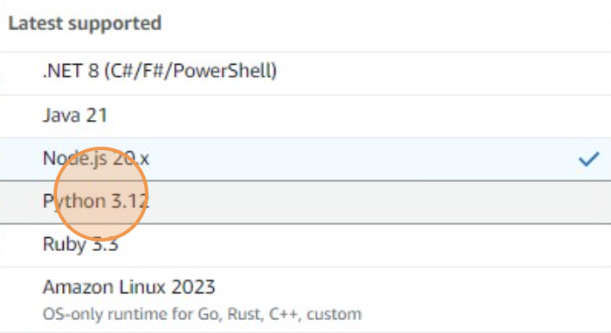

**Execution Role:**

* Click on **Change default Execution Role** option and select **Use an existing role** option.

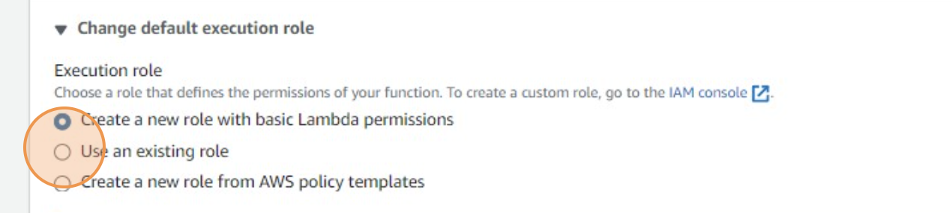

* Then under **Existing role** section select **lambdaathena** role

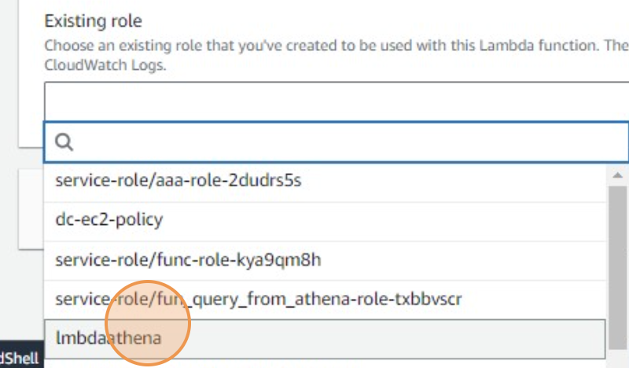

**Configure Trigger (Optional):**

* If there are specific triggers you need to set (like an API Gateway, S3 event, etc.), this would be the step to configure them. The steps provided are not detailed regarding the trigger configuration.

**Create the Function:**

* After setting the runtime and possibly triggers, click "**Create function**" to establish the Lambda function with the specified settings.

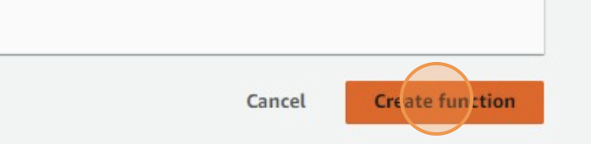

**Deploy the Function:**

* Click "**Deploy**" to deploy your code changes. This action makes your function ready to execute with the current configuration and code.

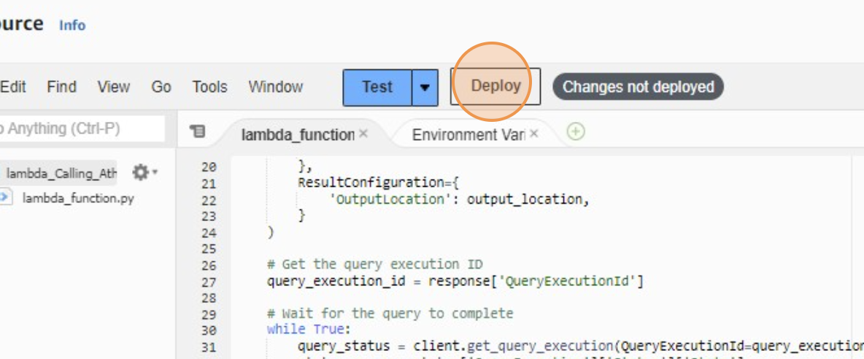

**Configure Test Event:**

* Click "**Configure test event**" to set up a sample input that simulates invoking the Lambda function. This is crucial for testing the function’s response to expected input.

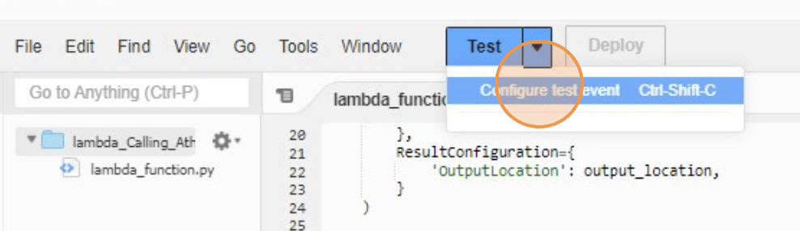

* In the "**Event name**" field, enter "**Athena_Queries_Running**" to name your test event.

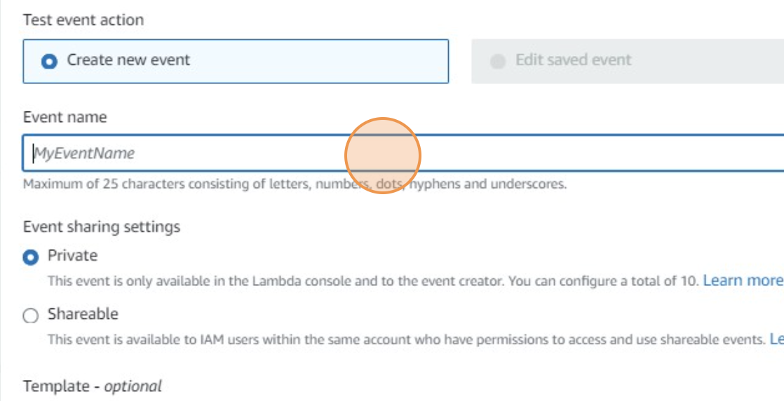

**Input Test Data:**

* Use keyboard shortcuts like ctrl + a (select all) and ctrl + v (paste) to input the test data into the configuration field. This data simulates the input your Lambda function will process when triggered.

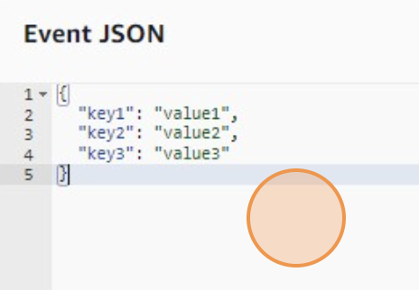

**Save Test Event:**

* Click "**Save**" to keep the configuration of your test event.

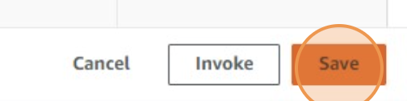

**Execute Test:**

* Click "**Test**" to run the Lambda function with the test event. This step is critical for verifying that your function processes the input as expected and connects to Athena correctly.

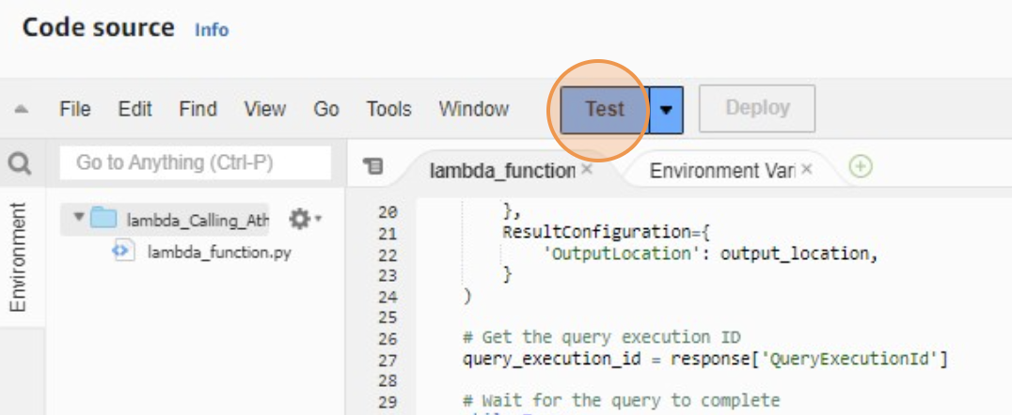

**Adjust Configuration:**

* Click "**Configuration**" and then "**Edit**" to modify settings such as execution role, memory, and timeout settings.

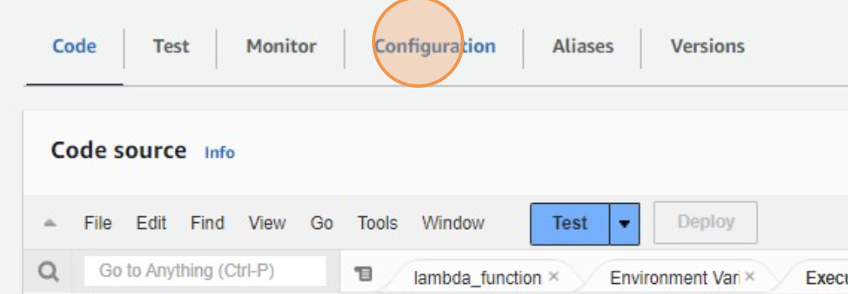

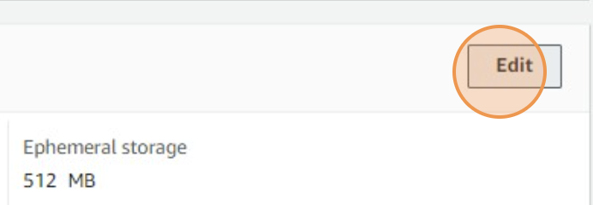

* In the "**Timeout**" field, type "**10**" and press the tab key, then type "**0**" to set the function’s timeout to 10 seconds, ensuring that the function does not run longer than necessary.

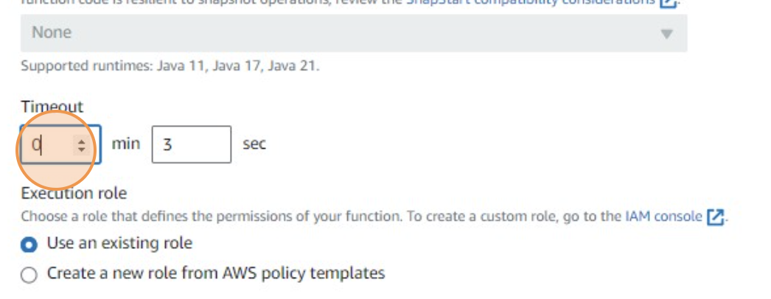

**Save Configuration Changes:**

* Click "**Save**" after making any necessary changes to ensure all configurations are updated.

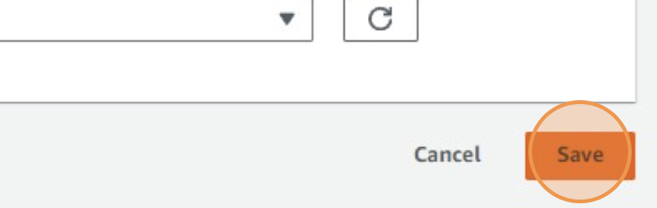

**Review and Test Code:**

* Click "**Code**" to view and edit the source code of the Lambda function. Ensure the code is correct and capable of querying Athena as intended.

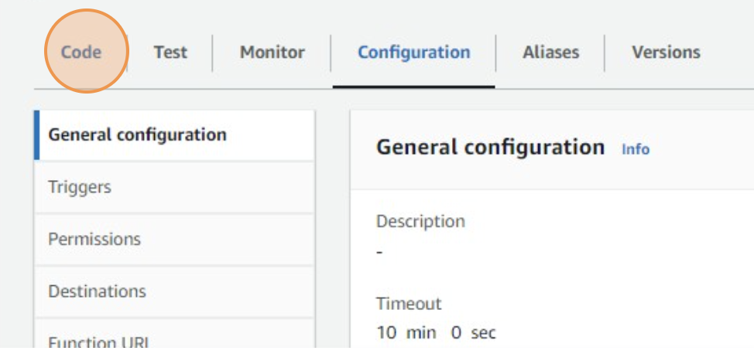

* Test the function again after any code modifications to confirm functionality.

**Final Verification:**

* Perform a final check by clicking "**Test**" again to ensure that all settings are correct and the function performs as expected with the configured test event.

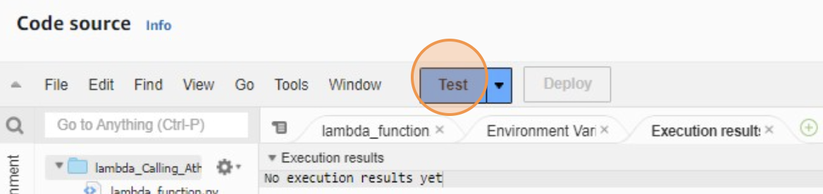

**Voila!!** We have successfully completed this exercise.